𝑯𝑨𝑪𝑲𝑨𝑻𝑯𝑶𝑵 𝑷𝑹𝑶𝑱𝑬𝑪𝑻

📌 CHARACTER COUNTER-count letters,words,and lines in typed text

•students names and roll numbers:

-P.sudheer(256Q1A4603)

-M.Sai Krishna(256Q1A4606)

-P. chetan(25821A4602)

-Poorna Jaswanth(2582144605)

-K. Suraj(2582144612)

Department: computer science and cybersecurity

Institute:Kakinada institute of technology

Academic year:2025

Code

sample_text = " enter any text.\n enter any text ."

letters, words, lines = count_text(sample_text)

print(f"Sample Text:\n---\n{sample_text}\n---")

print(f"Letters: {letters}")

print(f"Words: {words}")

print(f"Lines: {lines}")

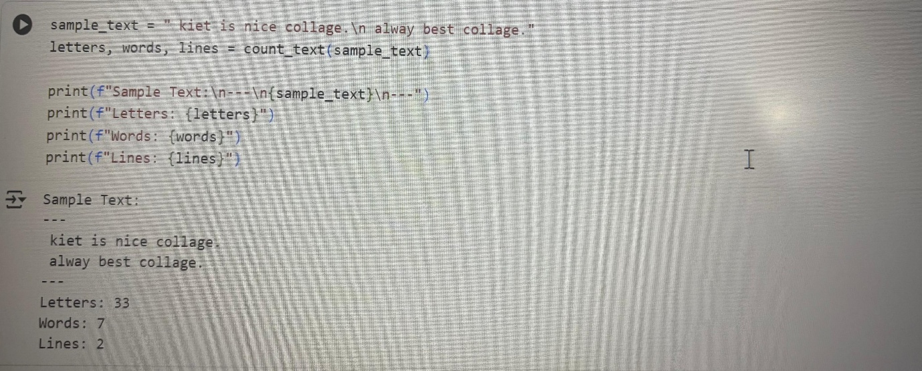

Problem statement:

Create a Python program called Character Counter that takes a piece of text as input and counts:

• The number of letters (characters)

• The number of words

• The number of lines in the given text.

The program should then display these counts to the user.

Explanation:

* text.isalpha() → Checks if a character is a letter (ignores spaces, punctuation, etc.)

* text.split() → Splits text into words by spaces/newlines.

* text.splitlines() → Splits text into separate lines.

* Function returns the three counts, which are printed in a formatted way.

Implementation:

The implementation of the Character Counter program is done in Python.

The program defines a function count_text() which takes a string as input and returns the number of letters, words, and lines in the text.

Below is the python code implementation :

# Function to count letters, words, and lines

def count_text(text):

letters = len([ch for ch in text if ch.isalpha()]) # Counts alphabetic characters

words = len(text.split()) # Counts words by splitting on whitespace

lines = len(text.splitlines()) # Counts lines by splitting on newline

return letters, words, lines

# Sample input text

sample_text = " enter any text.\n enter any text."

# Calling the function

letters, words, lines = count_text(sample_text)

# Displaying the results

print("Sample Text:\n---")

print(sample_text)

print("---")

print(f"Letters: {letters}")

print(f"Words: {words}")

print(f"Lines: {lines}")

Conclusion:

The Character Counter program successfully counts the number of letters, words, and lines in a given text using Python.

This project demonstrates the use of basic string manipulation functions such as split(), splitlines(), and isalpha().

It also shows how to define and use functions to structure code efficiently.

Overall, the project provides a simple yet effective way to analyze text input, which can be extended further into text processing or word-count applications.

* thank you -